Workflow:

1. Use the current AT value for each SNF model to examine the beta-Km diagram, and determine the best beta and Km for the model with N=3. For N=3 to have oscillation, Kd likely needs to assume a small value. Because longer loops increase robustness of oscillation, one would expect the same beta and Km to work for N=4,6,8,10. Altogether, beta and Km need to be determined for 6 different cases: 0L3, 0M3, 1L3, 1M3, 2L3, 2M3.
2. Regenerate Figure 3 based on the beta and Km chosen in Step 1.
3. Based on the beta and Km values in Step 1, for 0L8, 0M8, 1M8, 2M8 models, calibrate AMAX for NNF and PNF.
4. Use the beta, Km determined in Step 1 and AMAX determined in Step 3 to generate Figures 4 and 5.

Step 1&2 beta=4, Km=Ka=0.1

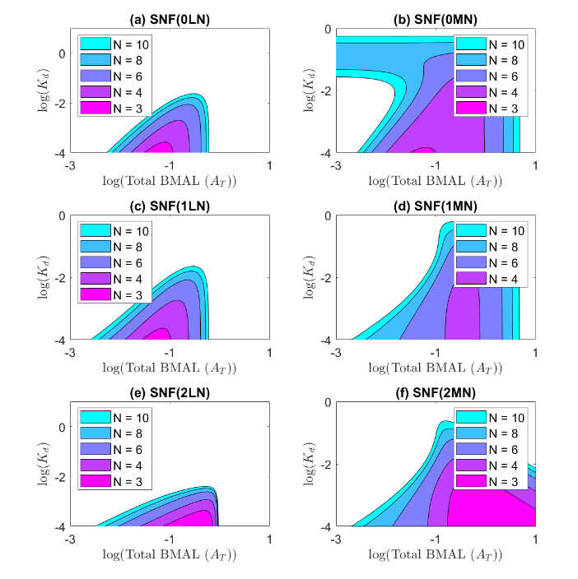

Step 3 Calibration of Amax for 0M8, 1M8, 2M8 models with Km=Kd=Ka=0.1

# Table S4. Parameter values used in the model simulations in Figures 4, 5 and Figures S3-S5.

|  |  |  |  |  |  |  |
| --- | --- | --- | --- | --- | --- | --- |
| Panel: | 4a | | | 4b | | |
| **Param** | **SNF**  **(0L8)** | **NNF**  **(0L8)** | **PNF**  **(0L8)** | **SNF**  **(0M8)** | **NNF**  **(0M8)** | **PNF**  **(0M8)** |
| *K*d | 0.001 | 0.001 | 0.001 | 0.1 | 0.1 | 0.1 |
| *K*A |  |  |  |  |  |  |
| *K*m |  |  |  | 0.1 | 0.1 | 0.1 |
| *β* |  |  |  | 4 | 4 | 4 |
| *A*T | 0.3 |  |  | 0.3 |  |  |
| *A*MAX |  | 0.65 | 0.55 |  | 0.7 | 0.54 |
| *δ* |  | 0.2 | 0.2 |  | 0.2 | 0.2 |
| *V*MAX |  | 5 |  |  | 5 |  |
| *R*MAX | 5 |  |  |  |  | 5 |

|  |  |  |  |  |  |  |
| --- | --- | --- | --- | --- | --- | --- |
| Panel: | 4c | | | 4d | | |
| **Param** | **SNF**  **(1M8)** | **NNF**  **(1M8)** | **PNF**  **(1M8)** | **SNF**  **(2M8)** | **NNF**  **(2M8)** | **PNF**  **(2M8)** |
| *K*d | 0.1 | 0.1 | 0.1 | 0.1 | 0.1 | 0.1 |
| *K*A | 0.1 | 0.1 | 0.1 | 0.1 | 0.1 | 0.1 |
| *K*m | 0.1 | 0.1 | 0.1 | 0.1 | 0.1 | 0.1 |
| *β* | 4 | 4 | 4 | 4 | 4 | 4 |
| *A*T | 0.3 |  |  | 0.3 |  |  |
| *A*MAX |  | 0.7 | 0.52 |  | 0.82 | 0.48 |
| *δ* |  | 0.2 | 0.2 |  | 0.2 | 0.2 |
| *V*MAX |  | 5 |  |  | 5 |  |
| *R*MAX |  |  | 5 |  |  | 5 |

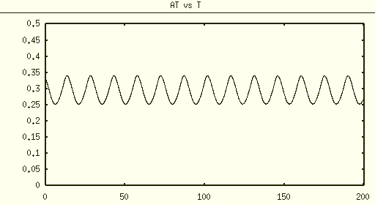

NNF 0L8 param Kd=0.001, delta=0.2, VMAX=5, AMAX=0.65

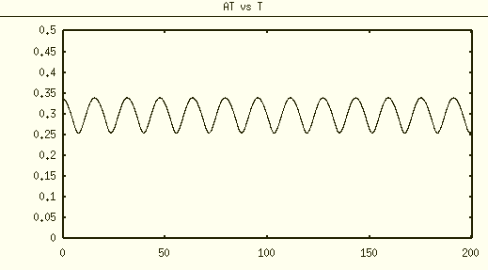

PNF 0L8 param Kd=0.001, delta=0.2, RMAX=5, AMAX=0.55

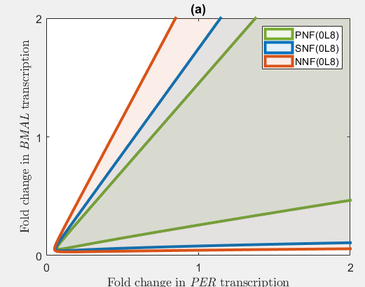

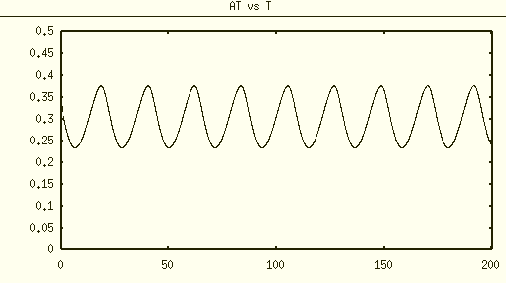

NNF 0M8 param Kd=0.1, delta=0.2, VMAX=5, AMAX=0.7

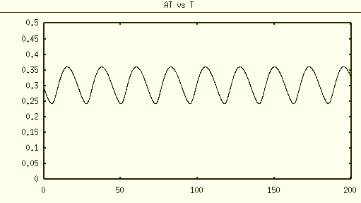

PNF 0M8 param Kd=0.1, delta=0.2, RMAX=5, AMAX=0.54

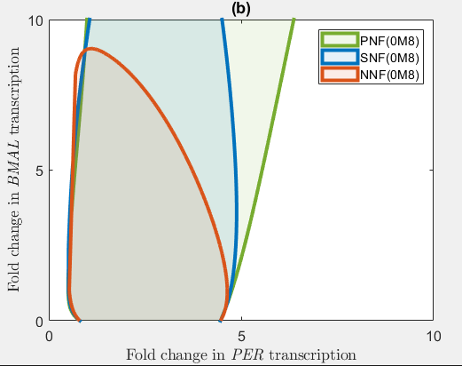

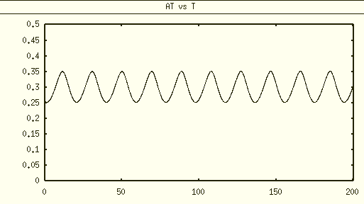

NNF 1M8 param Kd=0.1, delta=0.2, VMAX=5, AMAX=0.7

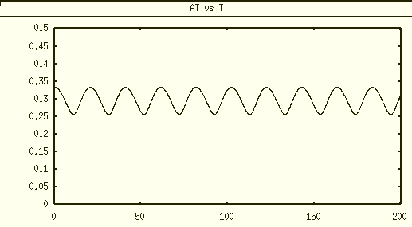

PNF 1M8 param Kd=0.1, delta=0.2, RMAX=5, AMAX=0.52

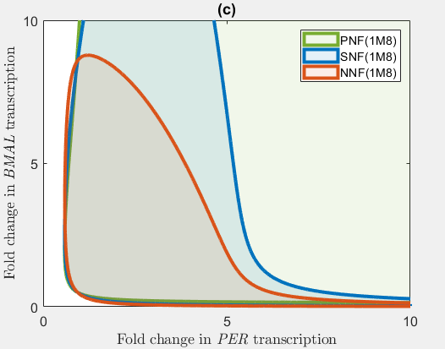

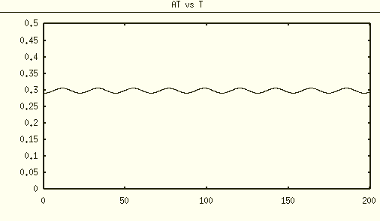

NNF 2M8 param Kd=0.1, delta=0.2, VMAX=5, AMAX=0.82

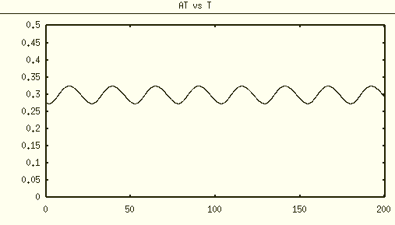

PNF 2M8 param Kd=0.1, delta=0.2, RMAX=5, AMAX=0.48

